LABORATORY WORK 8

SE-2226

Saparbek Imanzhusip

1)  
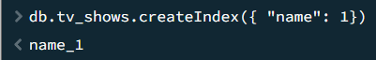

2)

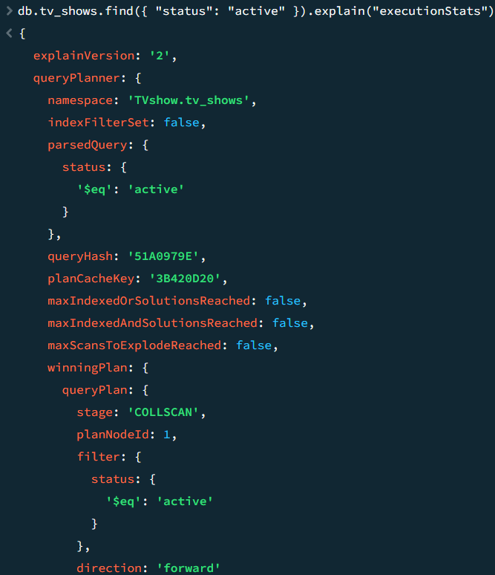

3)

* **Execution Stats**: This parameter provides detailed statistics about the execution of the query, including the number of documents scanned, the execution time, and more.
* **Stages**: The execution plan typically consists of different stages, such as "COLLSCAN" for collection scan or "IXSCAN" for index scan.
* **Index Usage**: If an index is utilized, it will show as "IXSCAN" (index scan) in the execution plan. It will specify which index is being used.
* **Filter**: This part of the plan indicates any filtering criteria applied during the execution of the query.

4

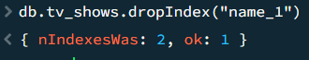

5



6

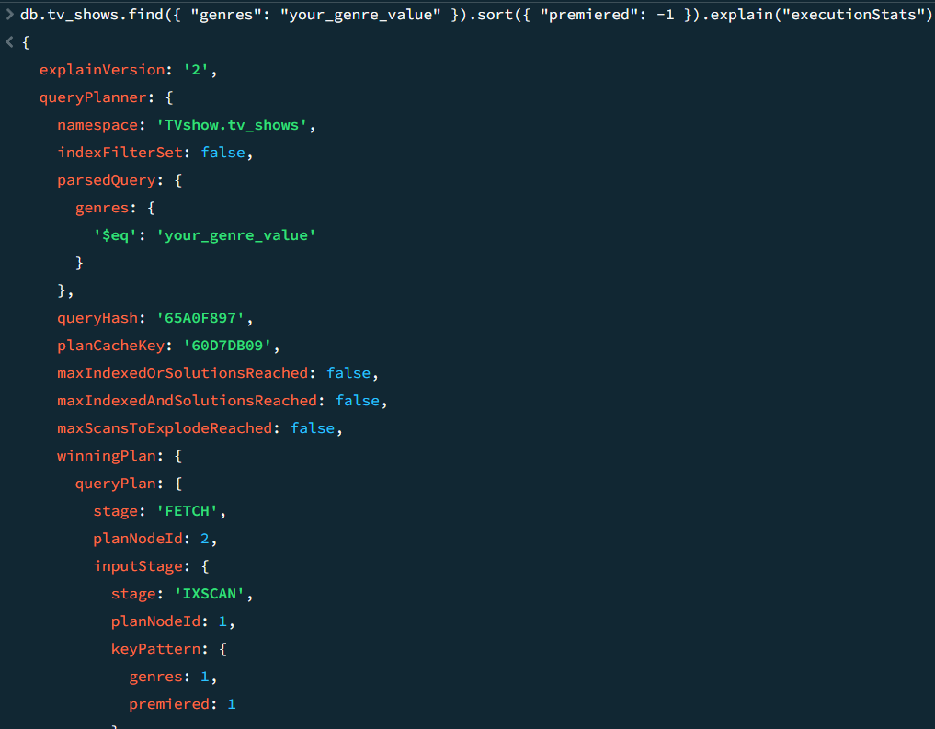

7

8

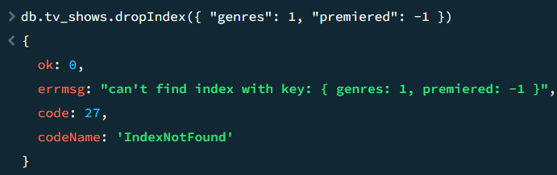

9



10

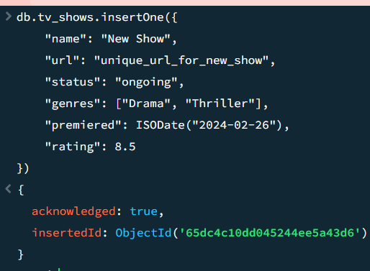

11

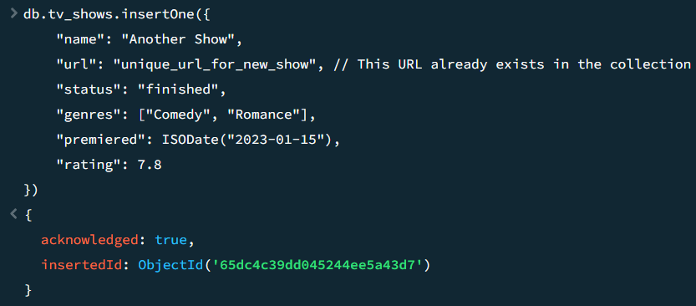

12

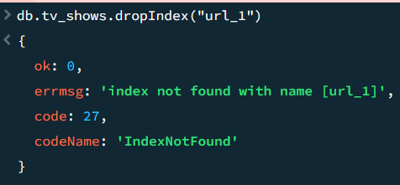

13

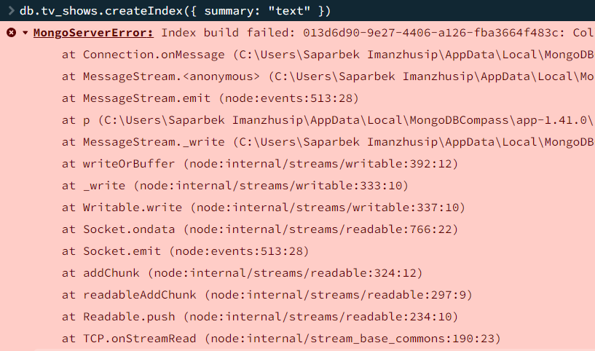

14

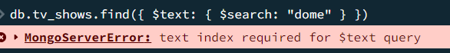

15

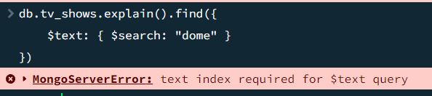

16

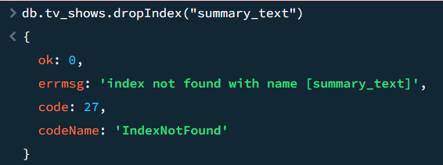

17



18

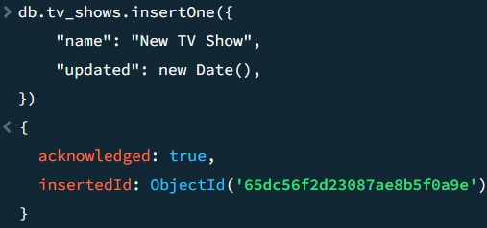

19

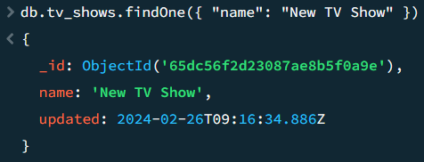

20

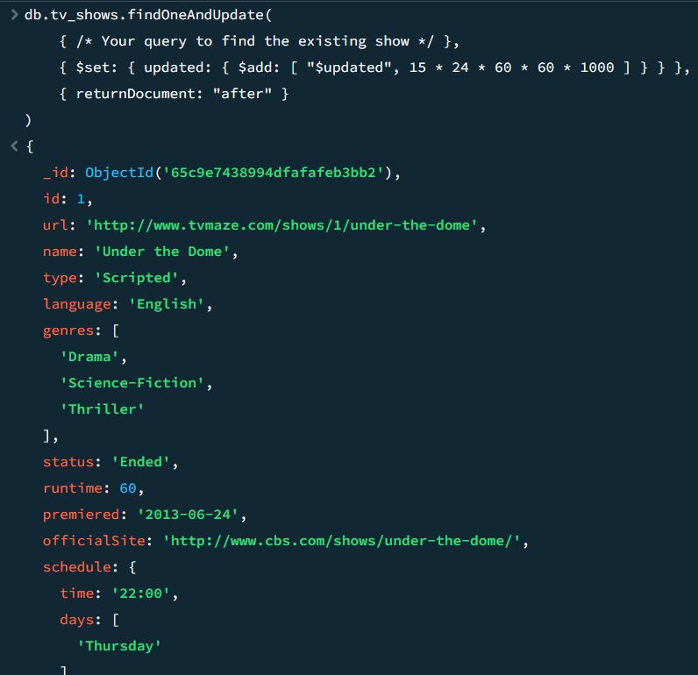

21

22

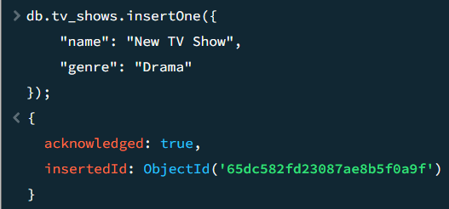

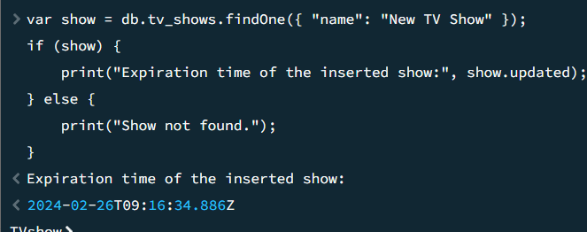

23

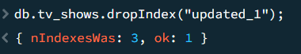

24

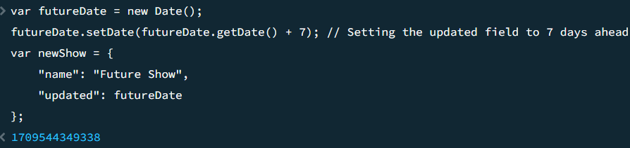

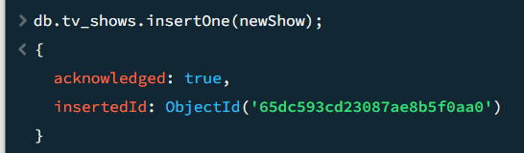

25

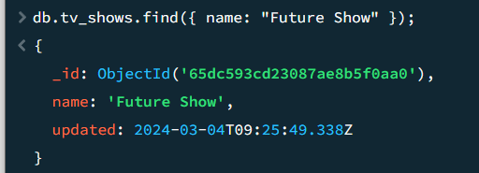

26



27

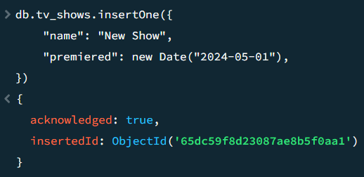

28

Create a TTL index on the "premiered" field with an expiration time of 1 minute for demonstration purposes



Insert a show with a "premiered" date that is within the next 90 seconds

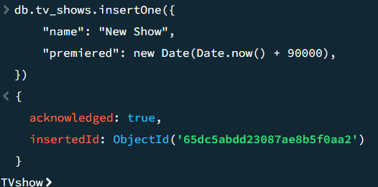

29

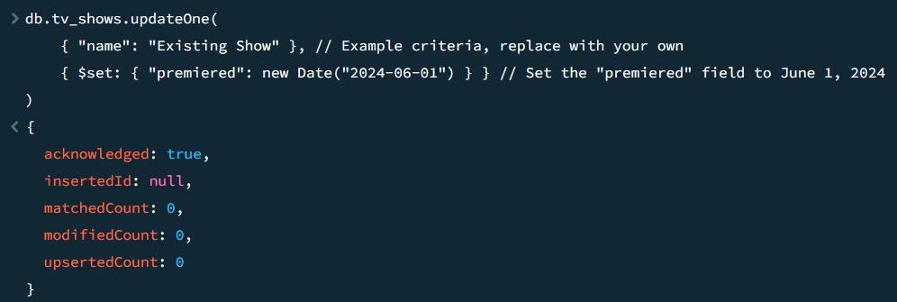

30

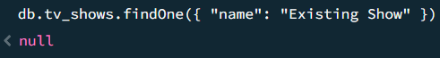

31



32

